To download fungi genomes
Go to https://mycocosm.jgi.doe.gov/mycocosm/home, logging in or creating a user account as necessary.
Navigate trough the phylogenetic tree until you get to where you want all the genomes. Here we use Aspergillus as an example:
Pick class.
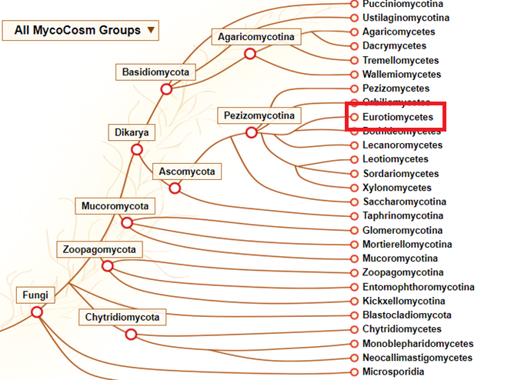

Then enter the tree for this class.
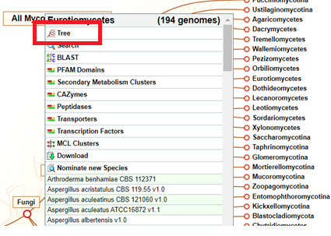
From now on you can pick what taxonomic level you want data for, this can be order, family, or genus. In this example we just pick the genus of Aspergillus.
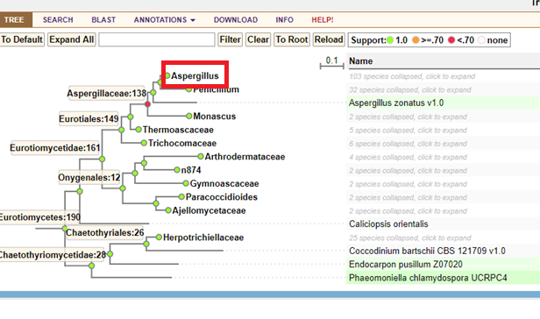
Click the download button when you have all the genomes present that you want
Be aware that unpublished genomes could be present, and you will be agreeing not to publish articles containing analyses of them.

Now pick the data you want for all the genomes and press download selected files.
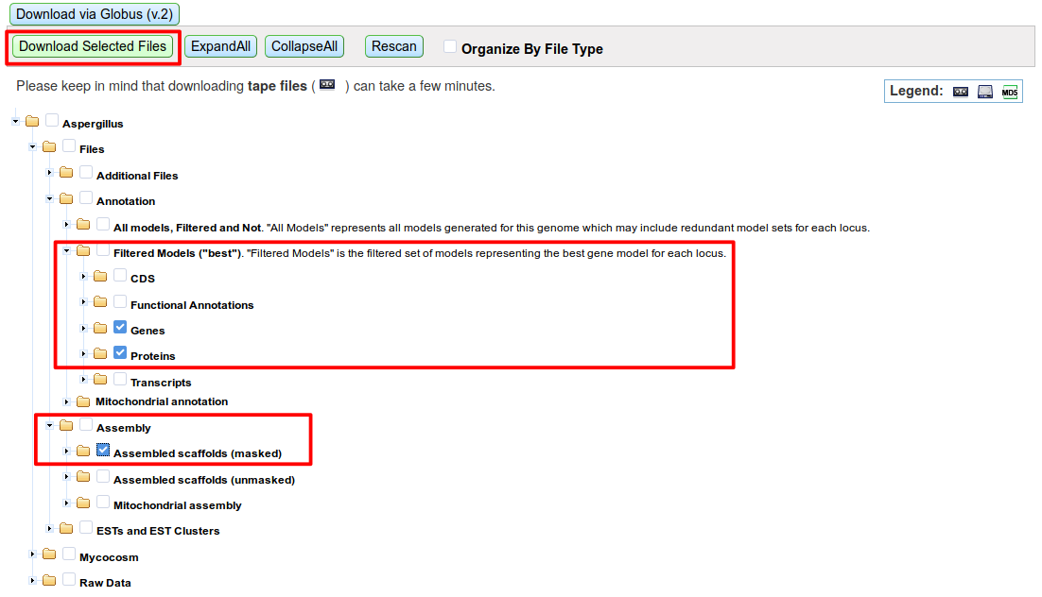
You will now download these files for all the genomes. (Might be a lot of data). You will get the files as a compressed archive of folders, where each file is itself compressed. You will need to unpack each file needed for the analysis (it’s recommended to do this with a bash script or the like.

